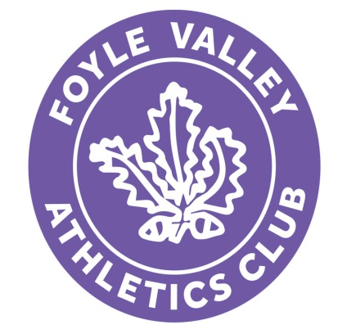

FOYLE VALLEY ATHLETICS CLUB
Consent Form for social media contact

If you are under 18, please also ask your parent/guardian to sign the form before it is returned. The club will also use this information to ensure that you are kept informed about club events.

I give permission for my child to be contacted by appropriate club staff online through Foyle Valley AC Youth Forum to be kept informed of club events, races and information.

Child’s Full Name:
Address:
Home Tel: Age:
Date of Birth: Male/Female (Please Circle)

Signature of Parent/Guardian* ______________________________

Print Name Date _________________________

Signature of Child: ______________________________

Print Name Date _________________________

Please return this form to the relevant Athletic Coach for your age group

